Jessica Hubbard, LCSW  Jessica Hubbard is a licensed clinical social worker who is rostered in Trauma-Focused Cognitive Behavioral Therapy (TF-CBT) and Structured Psychotherapy for Adolescents Responding to Chronic Stress (SPARCS). Jessica has been trained in Dialectical Behavioral Therapy (DBT) and incorporates DBT concepts into her work. She received her Master of Social Work degree from  the University of North Carolina at Chapel Hill. She specializes in working with children, adolescents, and young adults, specifically around trauma and chronic stress. | Christian Fisher, LCSW  Christian Fisher MSW LCSW completed the DBT intensive training in 2010. Christian is a member of a DBT consultation team and has co-facilitated a DBT Skills Class for Adolescents. Since 2009, Christian has provided school and office based mental health services in Chatham County. He received his Masters of Social Work from East Carolina University.

If anyone you know is interested in attending this class, please contact Jessica Hubbard at (919) 642-6937 or Christian Fisher at (919) 883-7771

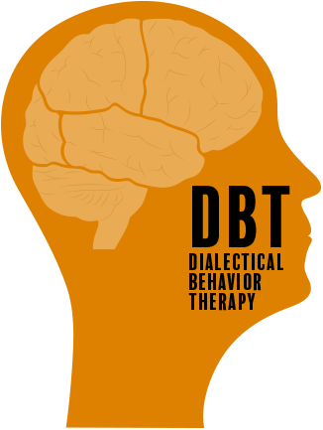



DBT Skills Class
Pittsboro, NC
Does your adolescent struggle with the following:
- Impulsivity
- Difficulty managing emotions
  - Quick temper, mood swings, outbursts, etc.
- Depression/Anxiety
- Self-harm
- Family Conflict
- Substance Use
- Binge Eating and/or Purging Behaviors

If so, they may be a great candidate for the DBT Skills Class for Adolescents!!

Facilitators:

